**Medindo Tracker Documentation**

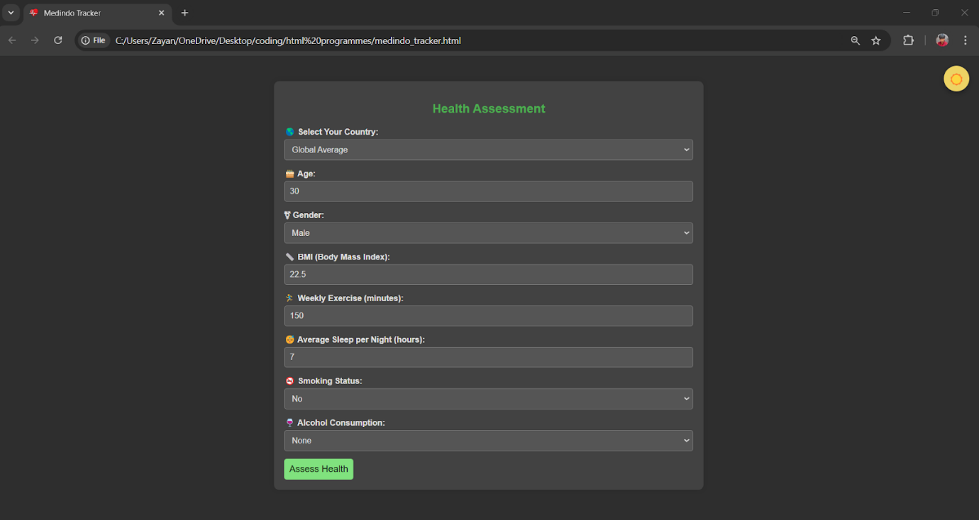

**Overview**

The **Medindo Tracker** is a web application for health checkups. Users can input various health-related metrics, and the application provides feedback and assessments based on the details entered.

**Table of Contents**

1. Features
2. Technologies Used
3. HTML Structure
4. CSS Styling
5. JavaScript Functionality
6. Usage
7. Future Enhancements

**Features**

* User-friendly interface for health checking.
* Dynamic theme switching (light/dark mode).
* Health checkup based on input details (age, BMI, exercise, etc.).
* Random health facts after checkup.
* Responsive design for various screen sizes.

**Technologies Used**

* HTML
* CSS
* JavaScript

**HTML Structure**

The HTML structure of the document consists of:

* **Head Section**: Contains metadata, a title, a favicon, and links to CSS styles.
* **Body Section**: Includes the main content:
  + A theme toggle button.
  + A health calculator form with input fields for various health metrics.
  + A loading spinner and an output display for results.

**Important Elements**

* **Button**: #theme-toggle for toggling themes.
* **Form Elements**: Various inputs (select and input) for user data.
* **Output Container**: Displays the results of the health assessment.

**CSS Styling**

The CSS provides styles for:

* General layout and responsiveness.
* Light theme and dark theme.
* Button hover effects with transitions.
* Loader and popup styling.

**Key Styles**

* **Body**: Basic styles for light and dark themes.
* **Buttons**: Shared styles for #theme-toggle and #calculate-button, including hover transitions.
* **Form Inputs**: Styling for input fields, focusing effects, and responsiveness.

**JavaScript Functionality**

JavaScript is used to achieve interactive functionality:

* **Theme Toggle**: Changes the theme and updates the button icon.
* **Health Assessment Calculation**: Collects user input, calculates health scores, and provides feedback.
* **Dynamic Output**: Displays the assessment results and random health tips.

**Key Functions**

* **Event Listeners**: For button clicks and form submissions.
* **Health Scoring Logic**: Evaluates user input to determine health status.
* **Random Fact Selection**: Selects three random health tips from a predefined list.

**Usage**

1. Open the HTML file in any web browser.
2. Fill in the health metrics in the form.
3. Click the "Assess Health" button to receive feedback.
4. View the results and health tips in the popup.

**`Future Enhancements**

* Integration with a backend for storing user data.
* More in-depth health assessments based on additional metrics.
* Enhanced UI/UX with animations and transitions.
* Mobile application version for broader accessibility.